**Ali Abbas Khan**

**24-CP-27**

**PF Lab No 8**

**Date 03-03-2025**

**Example No. 01**

Display numbers from 1 to 5 using while loop

**Codding and Output**

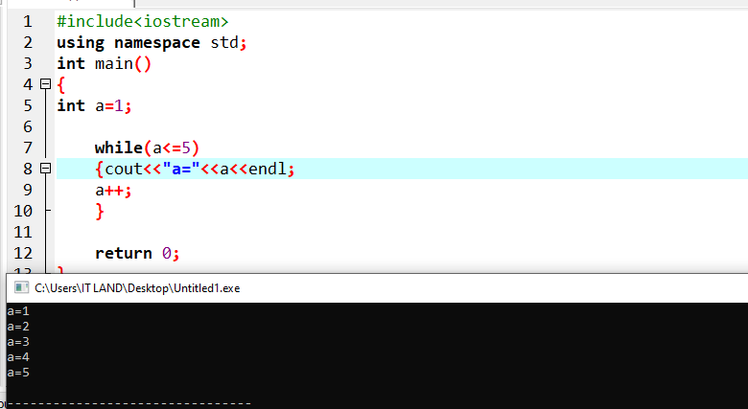

**Example No. 02**

Write a program to display sum of positive numbers using while Loop.

**Codding and Output**

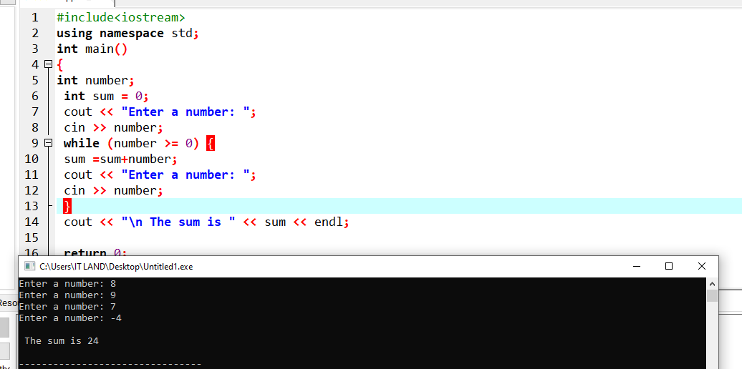

**Example No. 03**

Write a program to print value of variable in descending order.

**Codding and Output**

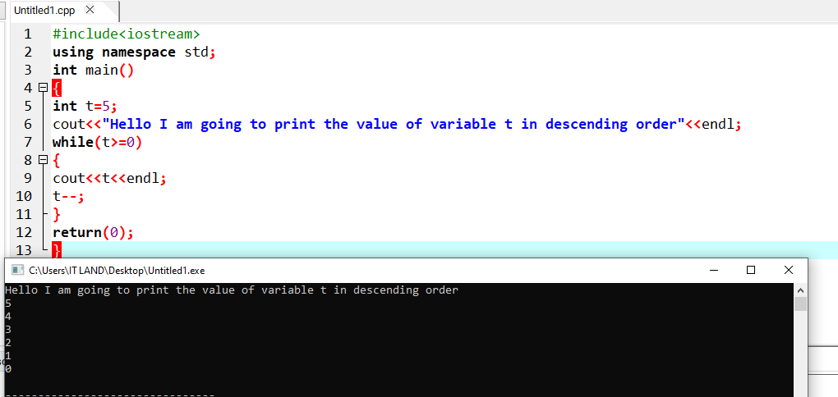

**Example No. 04**

Display the number of greetings “Hello”.

**Codding and Output**

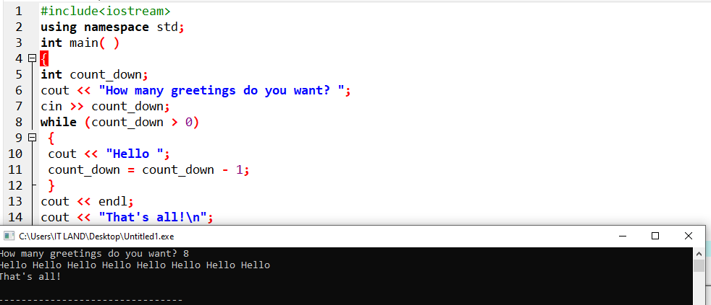

**Example No. 05**

Write a program to print the table of 10 using a while loop

**Codding and Output**

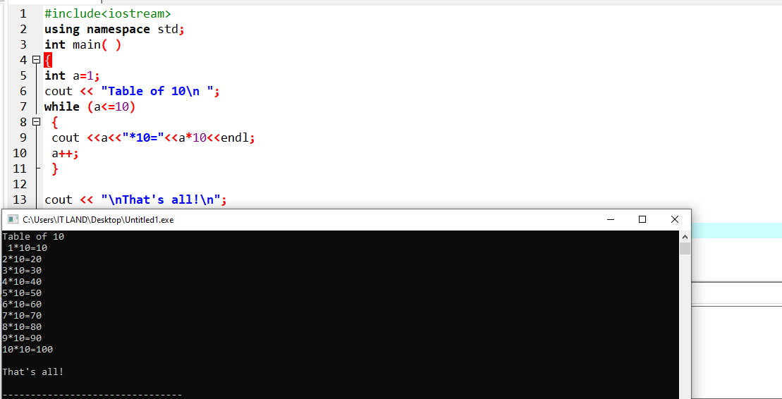

**Example No. 06**

Infinite while loop

**Codding and Output**

**Example No. 07**

Write a program to print value of X from 1 to 5 using do while loop

**Codding and Output**

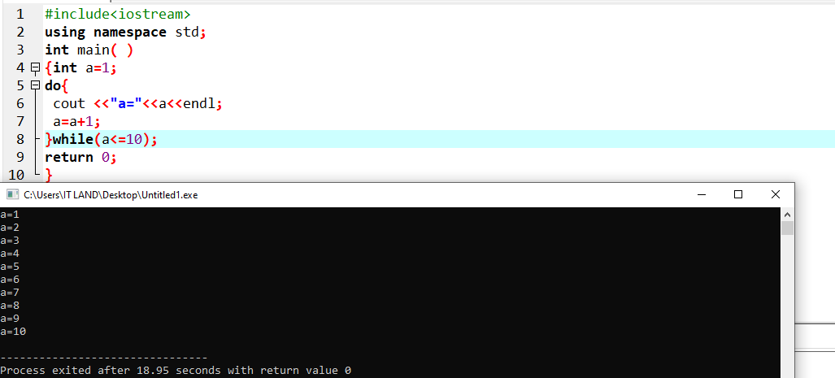

**Example No. 08**

: Write a program to calculate sum of all the numbers entered by user till the user enter the number “0” using do-while Loop.

**Codding and Output**

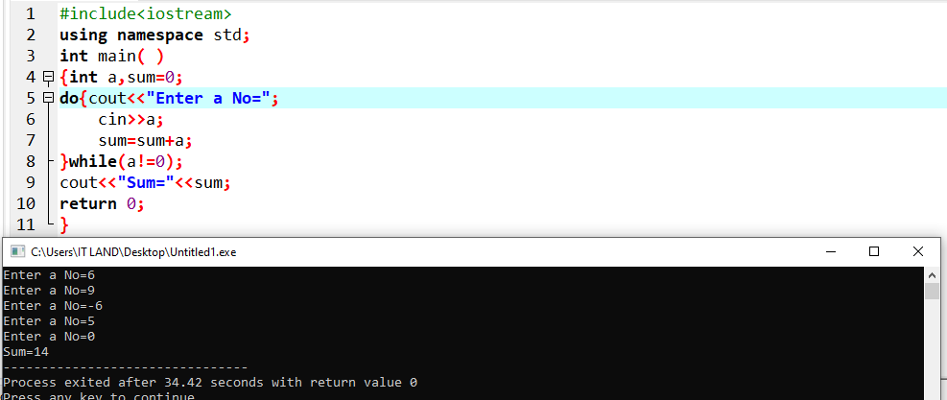

**Example No. 09**

Write a program to display numbers from 10 to 20 using do-while Loop.

**Codding and Output**

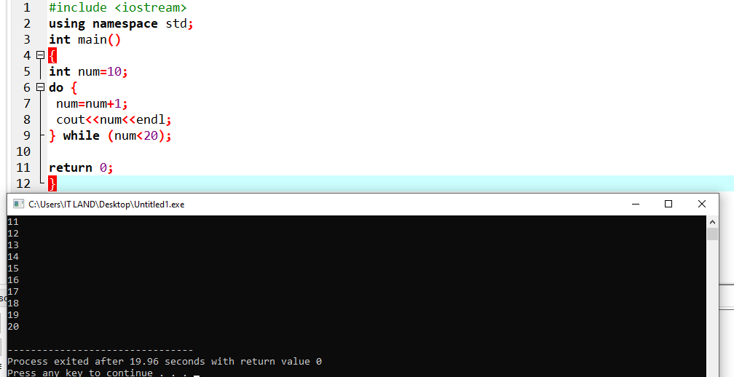

**Example No. 10**

Write a program using do-while loop to check whether an integer entered by the user is even or odd. Ask the user if he wants to continue with more numbers.

**Codding and Output**

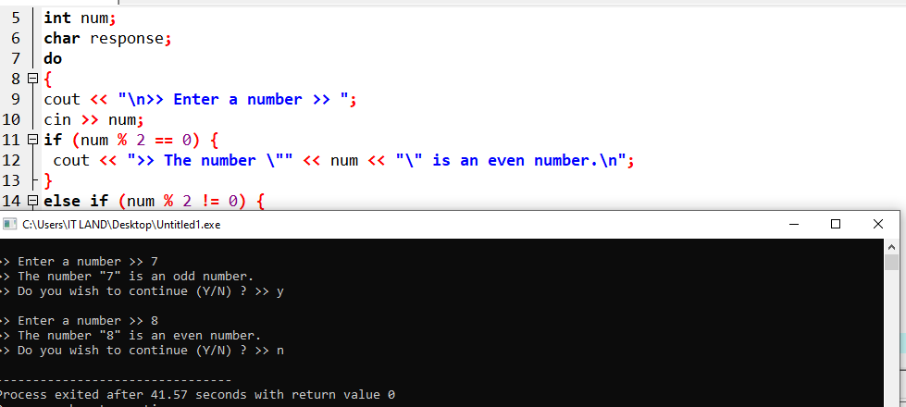

**Task 1**

Write a program that calculates sum of positive numbers less than 100 as soon as user enters negative number loop is terminated. Use break statement.

**Codding and Output**

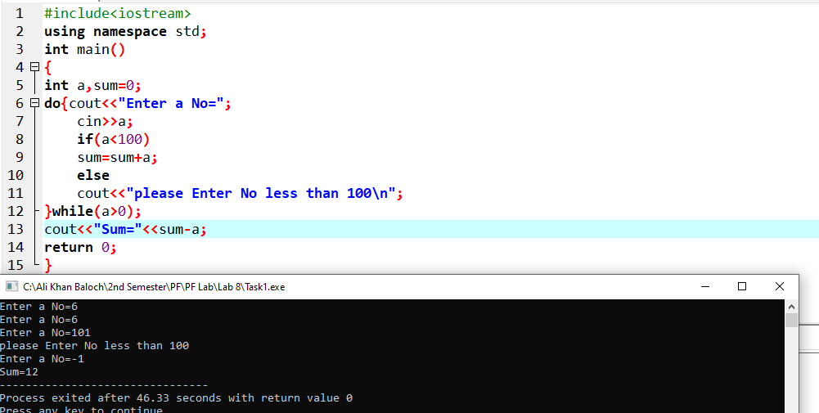

**Task 2**

Check if a Number is Prime or not using (while loop).

**Codding and Output**

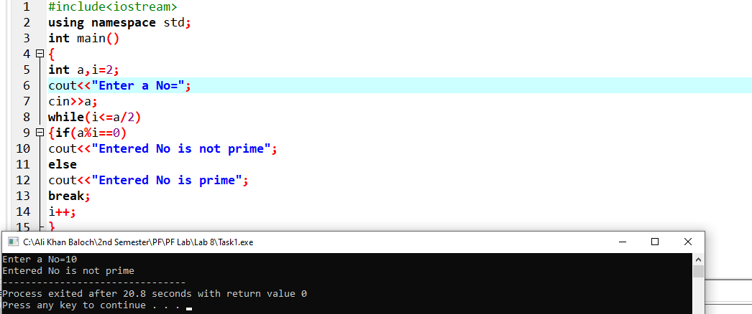

**Task 3**

Write a program to generate a Fibonacci series up till 200. Here are the first few terms of the series: 1 1 2 3 5 8 13 21 34 55 . Each term is found by adding the two previous ones: 1 + 1 𝑖𝑠 2, 1 + 2 𝑖𝑠 3, 2 + 3 𝑖𝑠 5, 3 + 5 𝑖𝑠 8, and so on. Do this while loop.

**Codding and Output**

